Five knowledge points:
1 Please list a number of generic activities common to all requirements engineering processes.
- Requirements elicitation
- Requirements specification
- Requirements verification and validation
- Requirements management

2. Please explain requirements elicitation and analysis.
Requirements elicitation - involves technical staff working with customers to find out about (tasks) the application domain, the services that the system should provide and the system’s operational constraints.
- May involve end-users, managers, engineers involved in maintenance, domain experts, trade unions known as stakeholders.
- Requirements discovery

- Requirements classification and organization
- Requirements specification

- Requirements prioritization and negotiation

3. Please explain Interviewing for the Requirements discovery.
They are 2 types of interviews, The first is Closed interviews which is based on pre-determined list of questions and the second one is Open interviews where various issues are explored with stakeholders.

4. Please give a detail description for the following user story.
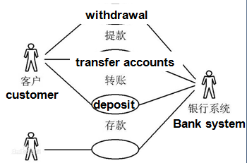

- A description of the starting situation;
- A description of the normal flow of events;
- A description of what can go wrong;
- Information about other concurrent activities;
- A description of the state when the scenario finishes.

5. Please list Form-based specifications for Structured specifications.
- Definition of the function or entity.
- Description of inputs and where they come from.
- Description of outputs and where they go to.
- Information about the information needed for the computation and other entities used.
- Description of the action to be taken.
- Pre and post conditions (if appropriate).
- The side effects (if any) of the function.

